**Lab 8 Summary**  
**Irvin, Mitchell**  
**Section 7441**  
**4/8/2016**

**Prelab question 1:**

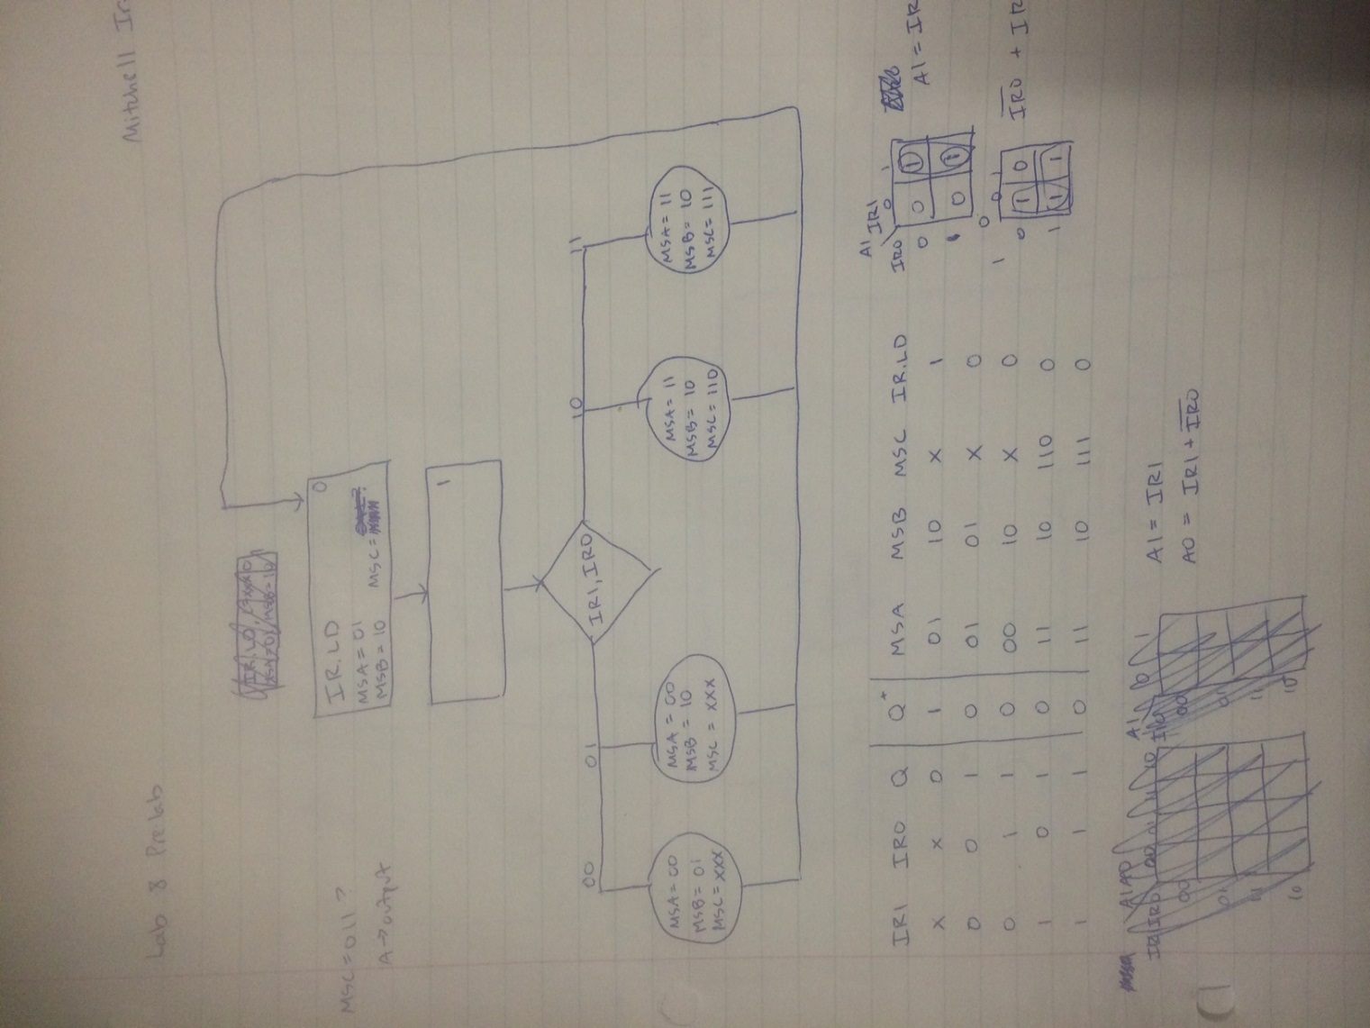

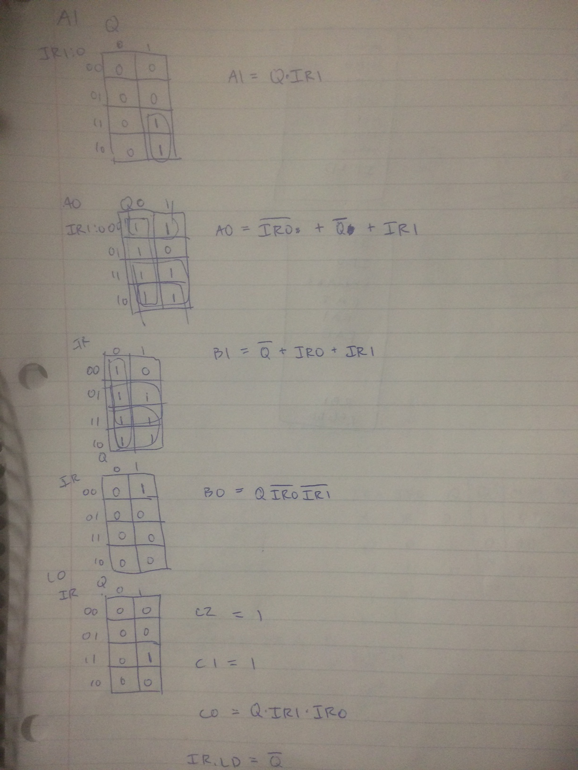

BDF of controller/ALU

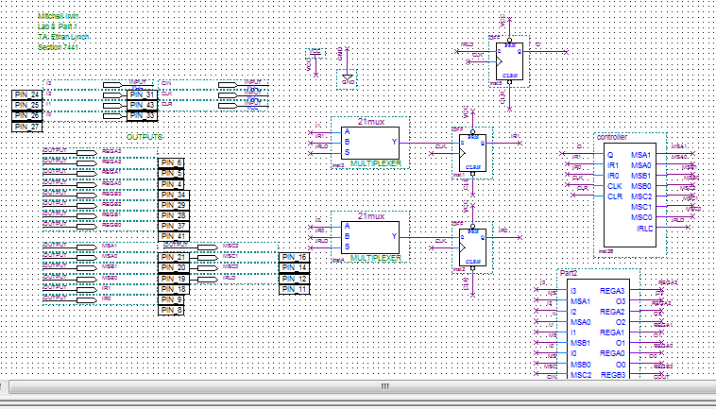

BDF of controller

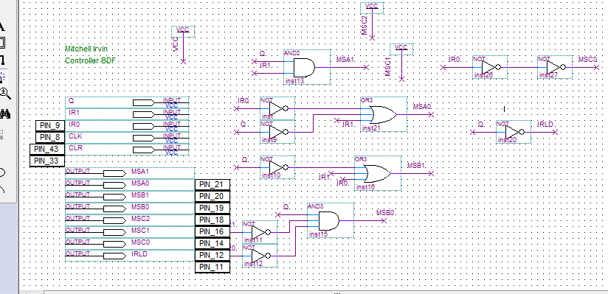

VWF output

